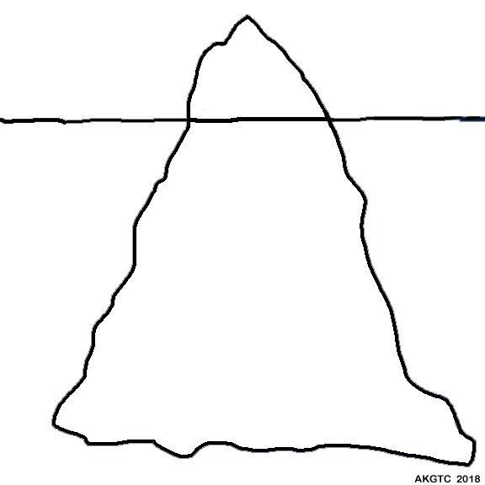
The Cultural
Iceberg

Visible

Less
Visible

Not
Visible

